Latihan soal Pertemuan 5
Muhammad Andhany Bahar/ 264107020150
TI 1C

Latihan 1
Flowchart:
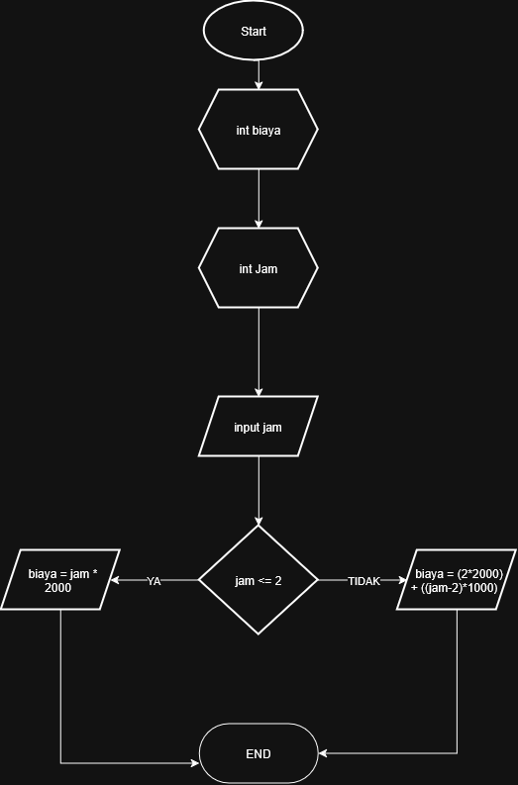

Pseudocode:
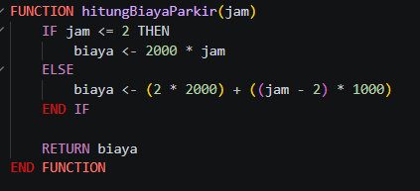

Java:
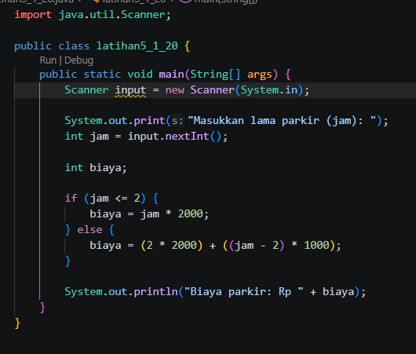

Latihan 2
Flowchart:
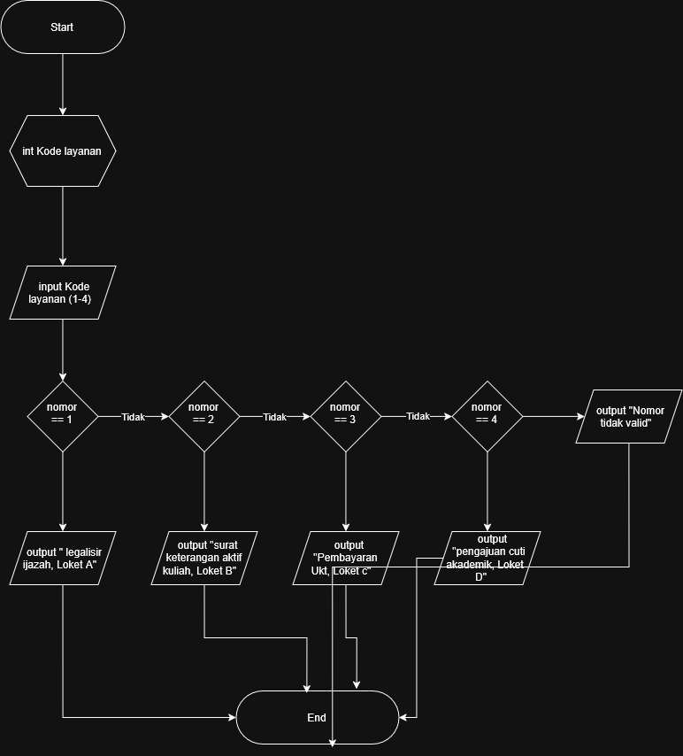

Pseudocode:

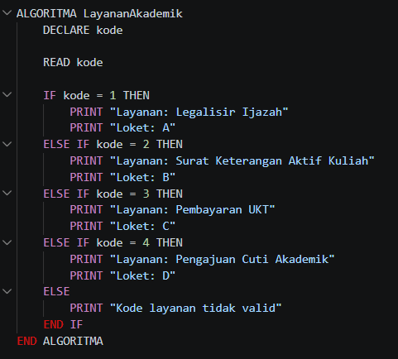

Java:
